中二級 中國歷史科 教學設計示例
（供收錄非華語學生的學校參考使用）
明代的政治發展概況

一.建議教節：4節

二.預期學習成果:
完成本課題後，學生能：
- 了解明朝建立、君主集權措施及影響（知識內容）
- 掌握明朝宦禍（知識內容）
- 認識晚明政局與明朝滅亡的關係。（知識內容）
- 透過閱讀文字資料、地圖、圖像、影片等，比較異同，分析史事。（知識內容、技能）
- 欣賞明太祖的開拓與創新精神。（情意、態度）

三.教學建議：
- 因應非華語學生的中文能力，工作紙較多圖像，部分題目輔以英文，協助學生理解內容。
- 題型包括選擇、圈示、填充等。思考題可因應學生的語文程度，或以口語回答。
- 教師可按學生學習情況加入討論環節，以增加學生之間的互動。
- 教師可鼓勵學生觀看網上影片，提升學習興趣。
- 教師教授課題時，除教授相關史實外，亦須指導學生認識中國的文明和文化，促進他們認識中國文化的特質。
- 教師可因應學生的程度而選取適合的部份或教學活動施教。

四.教學方案：
內容重點 | 流程 | 相關教材
課節一和二  明朝建立、君主集權措施及影響 | - 講解關鍵詞  - 運用圖像及影片等解釋明朝的建立  - 透過數據、圖像及影片等，說明君主集權政策及影響 | 圖像、  數據、  影片、  工作紙
課節三  明朝宦禍 | - 透過圖像及文字資料等，說明明朝宦禍，以及分析宦官弄權的影響 | 圖像、  文字資料、  工作紙
課節四  晚明政局與明朝滅亡 | - 運用時間線、圖像及影片等，說明晚明政局，以及解釋明朝滅亡原因 | 時間線、  圖像、  影片、  工作紙

備註：
- 學校可參考本教學計劃以調適課程內容，以配合學生的需要；
- 可因應學生的中文程度而刪去或減少當中的英文句子或詞彙；
- 可同時參考課程發展處出版的其他教材或為本課綱準備的其他示例；
- 可考慮向學生提供更多全方位學習經驗，如實地考察、參觀博物館等等。

XXX中學
中二級 中國歷史科課堂工作紙
明代的政治發展概況
(The political development of the Ming Dynasty)

姓名Name：________________ 成績Grade：_____／_____
班別Class：__________( ) 批改日期 Date of Marking：

學習重點(Learning Objectives)
- 明朝建立、君主集權措施及影響(The establishment of the Ming Dynasty, the measures and effects of the autocratic monarchy)
- 明朝宦禍(The problems caused by eunuchs in the Ming Dynasty)
- 晚明政局與明朝滅亡(Politics in the late Ming Dynasty and the downfall of the Ming Dynasty)

- 本節關鍵詞(Key Terms)

 | 英文詞彙 | 中文詞彙/粵語拼音 | 中文詞彙/普通話拼音
1 | Ming Dynasty | 明朝(ming4 ciu4) | 明朝(Míng cháo)
2 | Autocratic Monarchy | 君主集權(gwan1 zyu2 zaap6 kyun4) | 君主集權(jūn zhǔ jí quán)
3 | Emperor Taizu of the Ming Dynasty (Zhu Yuanzhang) | 明太祖(朱元璋)(ming4 taai3 zou2(zyu1 jyun4 zoeng1)) | 明太祖(朱元璋)( Míng  Tàizǔ (Zhū Yuánzhāng))
4 | abolition of the Chancellery | 廢除丞相(fai3 ceoi4 sing4 soeng3) | 廢除丞相(fèi chú chéng xiàng)
5 | court beating | 廷杖(ting4 zoeng6) | 廷杖(tíng zhàng)
6 | Eunuch | 宦官(waan6 gun1) | 宦官(huàn guān)
7 | Donglin factional struggles | 東林黨爭(dung1 lam4 dong2 zang1) | 東林黨爭(Dōnglín dǎng  Zhēng)
8 | Plague | 鼠疫(syu2 jik6) | 鼠疫(shǔ yì)
9 | Li Zicheng | 李自成(lei5 zi6 sing4) | 李自成(Lǐ Zìchéng)
10 | Emperor Chongzhen of the Ming Dynasty | 崇禎皇帝(sung4 zing1 wong4 dai3) | 崇禎皇帝(Chóngzhēn  huáng dì)

- 本節概要(Key Points of the Chapter)

明太祖(朱元璋)推翻元朝，建立明朝。他推行君主集權的措施。 | Zhu Yuanzhang was the founder of the Ming Dynasty that took over the rule from the Yuan Dynasty. He implemented the measures of the autocratic monarchy.
明朝宦官弄權，以致朝政腐敗。 | The eunuchs of the Ming Dynasty manipulated power, which led to the corruption of the administration.
民變隊伍攻入北京(首都)引致崇禎皇帝自縊。  清兵乘時入山海關，終致明代滅亡。 | The rebels captured Beijing the capital. Emperor Chongzhen committed suicide. The Qing army entered the Shanhaiguan Pass and the Ming Dynasty collapsed finally.

課節一和二：明朝建立、君主集權措施及影響(The establishment of the Ming Dynasty, and the measures and effects of the autocratic monarchy)
朱元璋推翻元朝，建立明朝。(Zhu Yuanzhang was the founder of the Ming Dynasty that took over the rule from the Yuan Dynasty.)
在他統治期間，他推行一系列君主集權措施。(He adopted a series of measures to reinforce the autocratic monarchy.)

資料一：明朝時間線(Source A:The timeline of the Ming Dynasty)
AD
公元
公元1368年，朱元璋建立明朝。(In 1368,Zhu Yuanzhang established the Ming Dynasty.)
公元1644年，明朝滅亡。(In 1644, the Ming Dynasty collapsed.)

1950
1250 1300 1350 1400 1450 1500 1550 1600 1650 1700 1750 1800 1850 1900

元朝 (Yuan Dynasty (1271年―1368年))
皇帝是蒙古人。(The emperors were Mongols.)
明朝 (Ming Dynasty (1368年―1644年))
皇帝是漢人。(The emperors were Han people.)
清朝 (Qing Dynasty (1636年―1912年))
皇帝是滿族人。(The emperors were Manchus.)

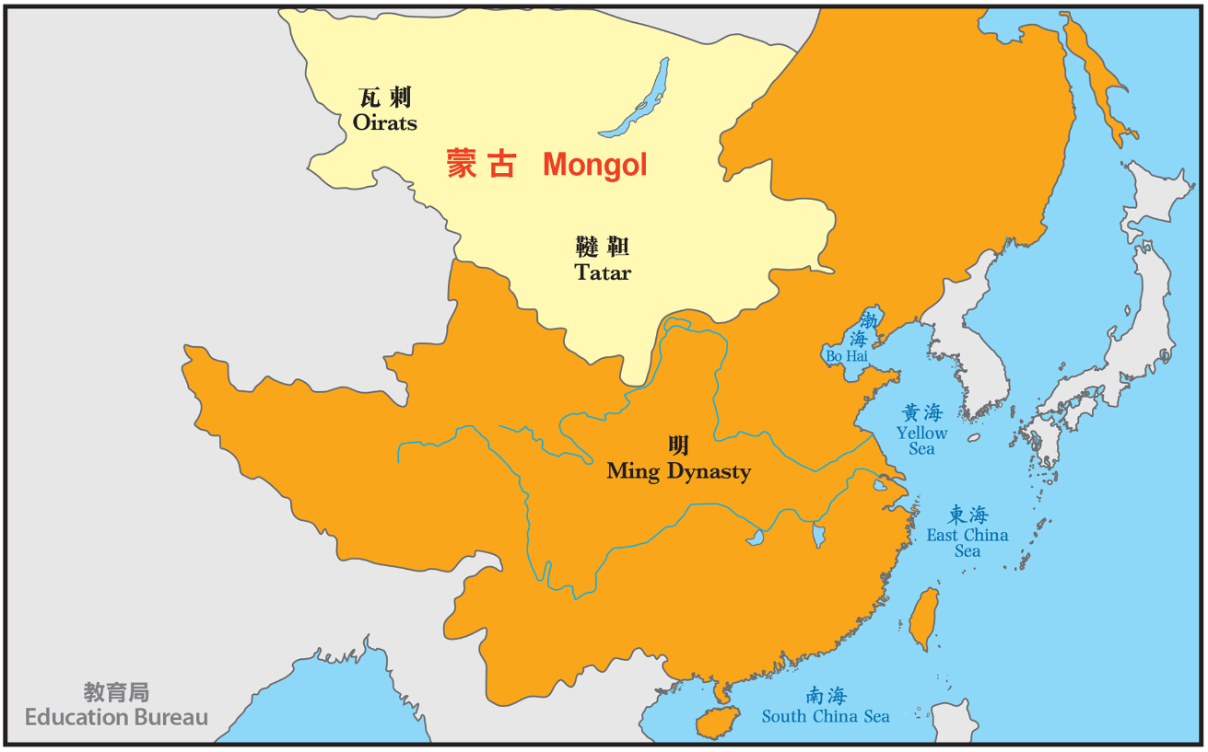
資料二：明朝地圖(公元1433年)(Source B: The map of the Ming Dynasty)(1433)

根據資料一及二，回答以下問題。(Study Sources A and B, and answer the questions.)

1. 明朝維持了多少年，請計算明朝的統治年期(寫出算式)。(Please calculate the ruling years of the Ming Dynasty (write down the equations).)
1644-1368=276 (年/years)

2. 以下哪個朝代由漢人統治？試圈出答案。(Which of the following dynasty was ruled by the Han people? Circle your answer.)
A. 元朝(The Yuan Dynasty)
B. 明朝(The Ming Dynasty)
C. 北魏(The Northern Wei Dynasty)

3.明朝是統一的國家還是分裂的國家？試圈出答案。(Was the Ming Dynasty a unified or a divided country? Please circle your answer.)
A. 統一(Unified)
B. 分裂(Divided)

I. 元末動亂與明太祖建國 (Uprisings in the late Yuan Dynasty and the establishment of the Ming Dynasty by Zhu Yuanzhang)

朱元璋推翻由蒙古人統治的元朝，建立由漢人統治的明朝。(Zhu Yuanzhang overthrew the Yuan Dynasty ruled by the Mongols and established the Ming Dynasty ruled by the Han people.)

資料三：月餅的故事(Source C: The Story of Mooncake)
請觀看(Please view：9:06-10:12)
https://emm.edcity.hk/media/%E4%B8%AD%E7%A7%8B%E7%AF%80%20(%E4%B8%AD%E6%96%87%E5%AD%97%E5%B9%95%E5%8F%AF%E4%BE%9B%E9%81%B8%E6%93%87)/0_b9jggy44

根據資料三，回答以下問題。(Study Source C, and answer the questions.)

4. 你知道這是甚麼嗎？你有沒有吃過？(Do you know what is it? Have you ever tasted this?) 月餅(mooncake) / 學生可自由作答 (Students can answer freely)
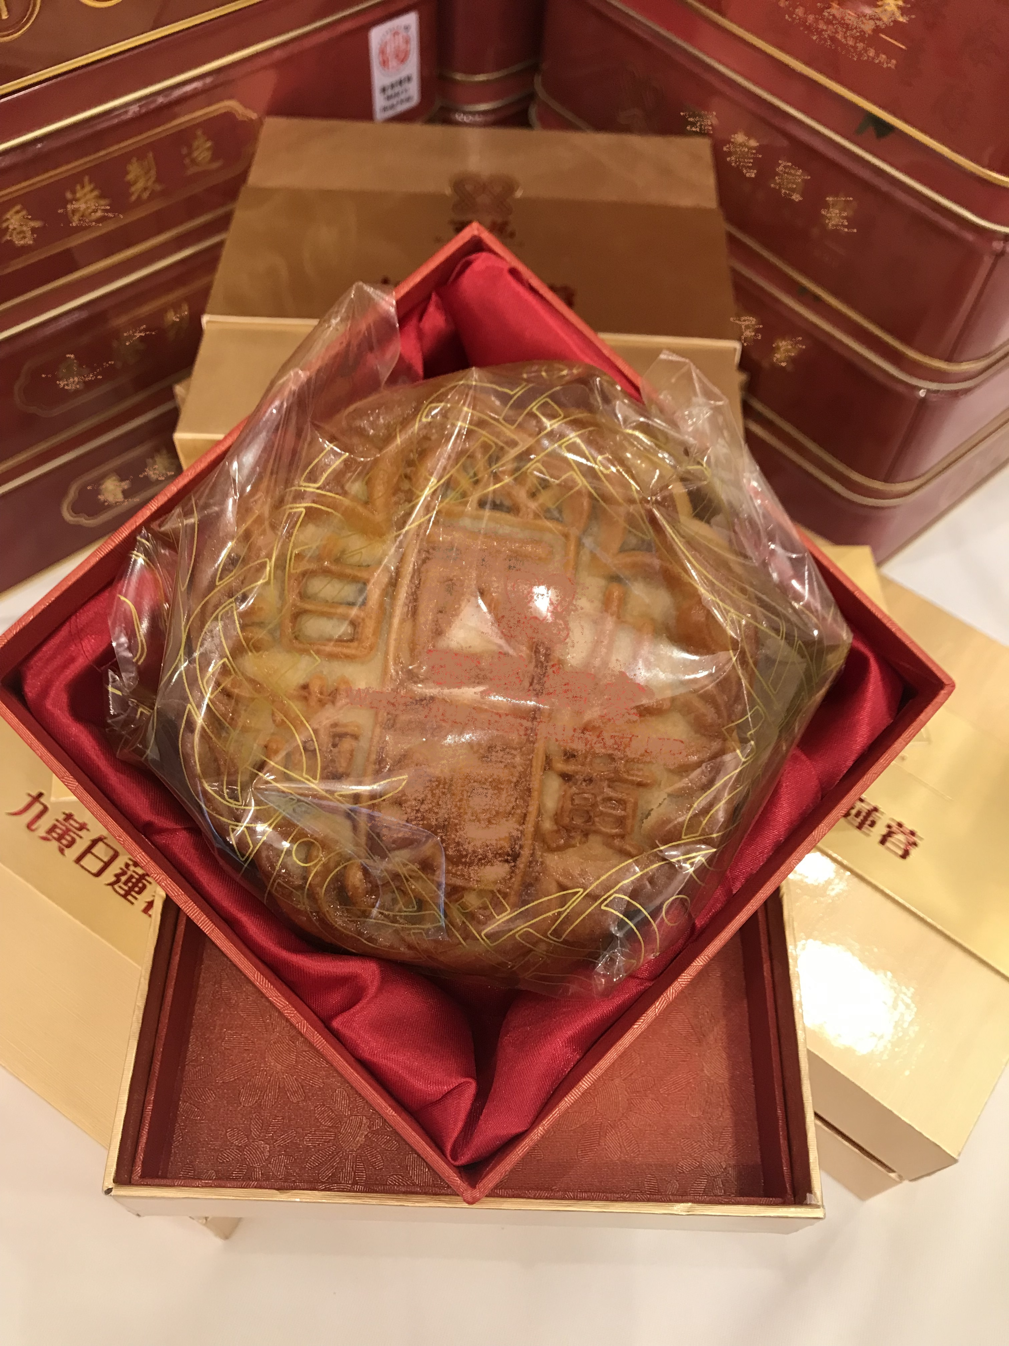

5. 中國人何時吃月餅？試圈出答案。(When do Chinese people eat mooncakes? Circle your answer.)
A.農曆新年(Chinese Lunar New Year)
B. 端午節(Dragon Boat Festival)
C. 中秋節(Mid-Autumn Festival)

6. 填充 (Fill in the blanks) ：
相傳吃月餅的節慶傳統，與 元朝 末年生的動亂有關。 蒙古 嚴厲的管治引發了全國的動亂。相傳朱元璋的軍事顧問劉伯溫在 月餅 中隱藏起義日期，分發及通知抗元軍在農曆8月15日晚上起事。這種策略有效，他們成功佔領了首都，從而開始了 明朝 的統治。
(The tradition of eating mooncakes during the festival is believed to be linked to the uprising in the late Yuan Dynasty. The harsh rule of the Mongol prompted a nationwide rebellion. It is said that Liu Bowen, the military advisor of Zhu Yuanzhang, came up with the idea of hiding notes containing the date of the uprising in mooncakes and distributed them to the rebels so as to inform the rebels to stage uprising at night on August 15 of the lunar calendar. The ploy worked, and they successfully took the capital and so began the Ming Dynasty.)

資料四：朱元璋(Source D: Zhu Yuanzhang)
朱元璋，又稱明太祖(統治時期1368-1398年)，是明朝的開國君主。他出身農民，後來出家成為僧侶，然後成為漢人反抗元朝統治的領袖，最後成為新朝代的第一個皇帝。(Zhu Yuanzhang, known as Emperor Taizu of the Ming Dynasty (ruled 1368–1398), was the founder of the Ming Dynasty. He was a peasant and became a monk later. Then he was a rebel leader of Han people against the rule of the Yuan Dynasty and finally became the first emperor of the new dynasty.)

7. 根據資料四，朱元璋出身於哪個階層？試圈出答案。(Study Source D, what was the origin of Zhu Yuanzhang? Circle your answer.)
A. 平民(commoner)
B. 貴族(nobility)

II. 君主集權措施與影響 (Measures and effects of the autocratic monarchy)

朱元璋成為皇帝後，把所有權力集中在自己手上。(After Zhu Yuanzhang became the emperor, he centralized all the power in his own hands.)

資料五：第三屆全港學界「中史解碼」短片創作比賽得獎作品精選(Source E: The Third Territory-wide Schools "Decoding Chinese history" Creative Video Competition's highlights)
高中組冠軍(Champion (Senior Secondary))
朱元璋(Zhu Yuanzhang)
請觀看(Please view 9:46 – 12:53)
https://emm.edcity.hk/media/1_kw8rsxsd

根據資料五，回答以下問題。(Study Source E, and answer the questions.)

8. 胡惟庸案及藍玉案中，明太祖分別誅殺了多少人？(In the Hu Weiyong’s case and the Lan Yu’s case, how many people were killed by Emperor Taizu of the Ming Dynasty?)
胡惟庸案Hu Weiyong’s case | 三萬多人(over 30 thousand people)
藍玉案Lan Yu’s case | 多達一萬五千人(over 15 000 people)

9. 明太祖誅殺哪類型人士？試圈出答案。(Which type of person did Emperor Taizu of the Ming Dynasty kill? Circle your answer.)
A. 大臣(officials)
B. 平民(commoner)

10. 為甚麼明太祖誅殺這些人士？試圈出答案。(Why did Emperor Taizu of the Ming Dynasty execute these people? Circle your answer.)
A. 有利整肅歪風，提高君威。(It was conducive to restore the discipline of the officials and consolidate emperor’s power)
B. 明太祖為保明室江山，將權力集中於君主身上。(Emperor Taizu of the Ming Dynasty wanted to safeguard his regime that he had founded and all the power were concentrated in the hands of the emperors.)
C. 以上皆是 (all of above)
資料六：明朝的中央政制(Source F: The central administration of the Ming Dynasty)
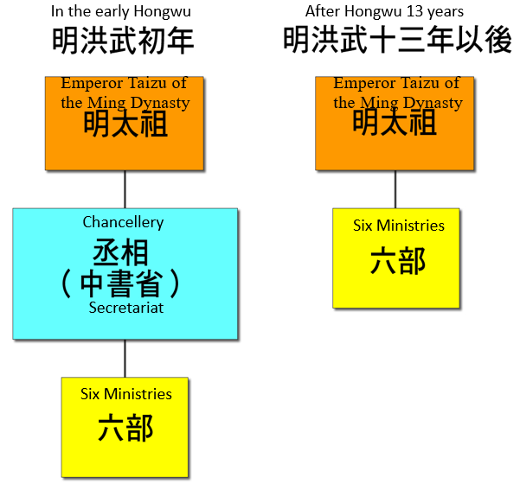

資料七：俄國彼得大帝的行政改革(Source G: Administrative reforms of Peter the Great of Russia)
彼得大帝改革之前，協助國家治理的政府官員主要來自貴族(波雅爾)。彼得大帝廢除了「波雅爾」制度，並將參議院確立為最高政府機構。參議院的所有成員均由彼得大帝任命。(Before the reforms of Peter the Great, government officials who helped in the governance of the state were mainly from the nobilities (Boyar). Peter the Great abolished the ‘Boyar’ system and established the Senate as the highest administrative institution. All members of the Senate were appointed by Peter the Great.)
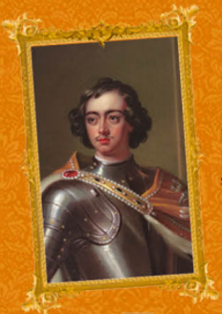

彼得大帝(Peter the Great) (1672–1725)
(圖像來源：皇室瑰寶：俄羅斯宮廷文物展展覽工作紙，香港歷史博物館，頁2。)

根據資料六及七，回答以下問題。(Study Sources F and G, and answer the questions.)

11.明初與洪武十三年(1380年)後的中央政制有什麼不同的地方？(What was the difference between the central administration in early Ming and that after 1380?)
明太祖廢除 丞相 ，令中央的 六部 ，直接對 皇帝 負責。(Emperor Taizu of the Ming Dynasty abolished the post of Chancellor. Six Ministries were directly responsible to the emperor.)

12.明太祖及彼得大帝的改革有何相同目的？試圈出答案。(What was the same purpose of the reforms of Emperor Taizu of the Ming Dynasty and Peter the Great? Circle your answer.)
A. 減少宦官的權力(To eliminate the power of eunuchs)
B. 防止軍人割據奪權(To prevent generals from taking over control of different regions and challenge the imperial power)
C. 提升君權 (To increase the power of the emperors)
D. 裁減多餘官員(To cut down redundant officials)

13. 填表(Fill in the table)
 | 明太祖改革(reforms of Emperor Taizu)) | 彼得大帝改革(reforms of Peter the Great)
針對的對象(targeted person) | 大臣(officials) | 貴族(nobilities)

資料八：明太祖的日常工作(Source H: Daily work of Emperor Taizu of the Ming Dynasty)
日期(Date) | 洪武17年（1384年）9月14日- 21日(During the 17th year of the reign of Hongwu, 14 – 21 September, 1384)
處理文件數目(no. of documents handled) | 1660
處理事情數目(no. of cases handled) | 3291

根據資料八，回答以下問題。(Study Source H, and answer the questions.)
14.明太祖平均每日要閱讀多少份文件及要處理多少件事情﹖(How many documents and cases did Emperor Taizu of the Ming Dynasty read and deal with each day in average?)
處理文件數目(no. of documents handled) | 約208件(about 208)
處理事情數目(no. of cases handled) | 約411件(about 411)
15. 你認為明太祖的工作量怎樣﹖(What can you say about the workload of Emperor Taizu of the Ming Dynasty?)
工作量巨大。(Heavy workload)

16. 明太祖會有如此的工作量與他實行的哪一項集權措施有關﹖(Which measure of the autocratic monarchy contributed to the working condition of Emperor Taizu of the Ming Dynasty?)
明太祖廢除丞相。(Emperor Taizu of the Ming Dynasty abolished the post of Chancellor.)

17.明太祖實行這項措施有何好處及壞處？為甚麼﹖可以口語回應。(What were the advantage and disadvantage of Emperor Taizu's adoption of this measure? Why? You can respond verbally.)
好處：可鞏固君主權力。(Advantage: The measure could consolidate the power of the emperor.)
壞處：會加重皇帝的工作量，無法兼顧眾多事務，而可能導致國政日壞。(Disadvantage: The measure could increase the emperor's workload as the emperor was not able to take care of many cases. This might lead to deterioration of administration.)

資料九：刑罰(Source I: Punishment)
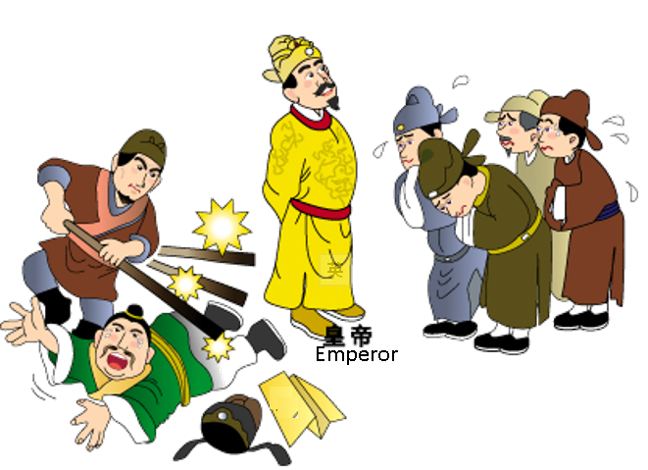

根據資料九，回答以下問題。(Study Source I, and answer the questions.)

18.明太祖對偶犯過失的大臣使用甚麼刑罰？試圈出答案。(What kind of punishment did Emperor Taizu of the Ming Dynasty use against officials who committed negligence? Circle your answer.)
A. 炮烙(roasting at a burning pillar)
B. 廷杖(court beating)
C. 肉刑(mutilation)

19. 明太祖為甚麼對大臣使用這種刑罰？試圈出答案。(Why did Emperor Taizu of the Ming Dynasty use this punishment against officials? Circle your answer.)
A. 折辱大臣(To humiliate officials)
B. 提升君權(To increase the power of the emperors)
C. 以上皆是(all of above)

資料十：香港的鞭笞刑罰 - 九尾鞭(Source J: Caning in Hong Kong - The cat-of-nine tails)
利用九尾鞭進行笞刑以懲罰罪犯。(Caning by using cat-of-nine tails was a punishment commonly used on criminals.)
笞刑於1990年正式廢除。(This sort of corporal punishment was abolished in 1990.)
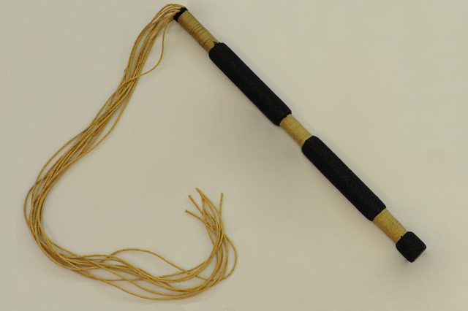

(圖像來源：https://www.csd.gov.hk/emuseum/gallery1_en.html#ad-image-5，觀看日期：2021年9月10日)
根據資料九及十，回答以下問題。(Study Sources I and J, and answer the question.)
20. 填表(Fill in the table)
 | 明朝(Ming Dynasty) | 香港(Hong Kong)
懲罰的對象(The punishment was applied to:) | 大臣(officials) | 罪犯(criminals)
小總結 (A short summary)
明太祖透過廢除丞相、折辱大臣等，以強化皇權。(Emperor Taizu of the Ming Dynasty strengthened the imperial power through the abolition of the Chancellery and the humiliation of officials by court beating.)
課節三：明朝宦禍(The problems caused by eunuchs of the Ming Dynasty)
明朝宦官弄權，以致朝政日敗。(Power abuse of eunuchs of the Ming Dynasty led to the corruption of the administration.)

資料一：明朝君臣處理政事的流程 (Source A: The workflow of administration by emperors and members of the Grand Secretariat in the Ming Dynasty)
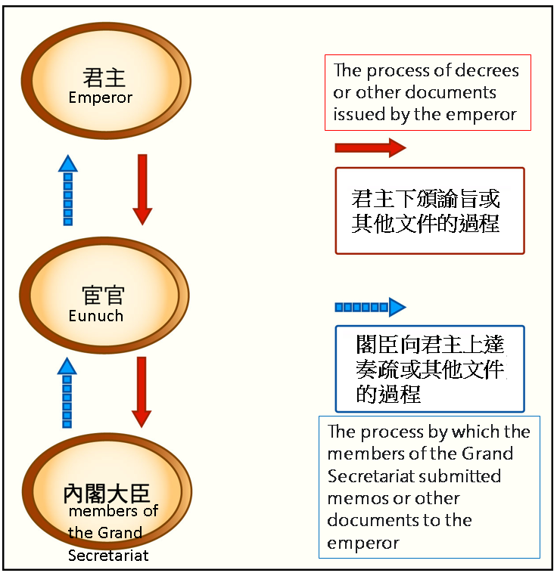

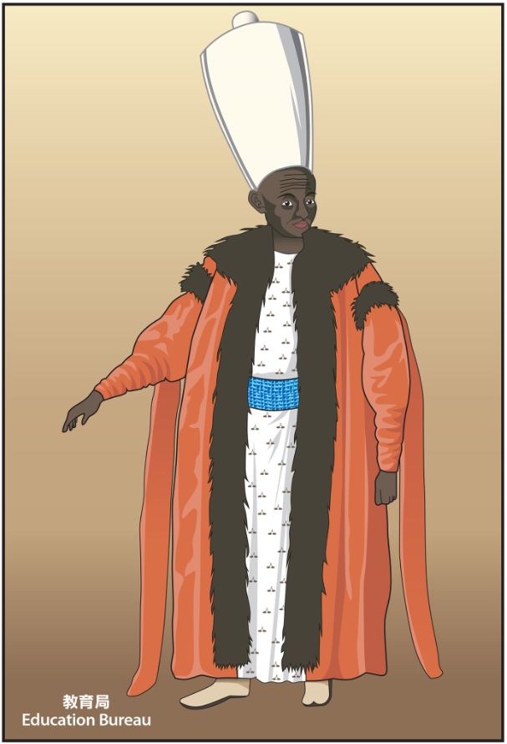
資料二：在鄂圖曼帝國後宮工作的太監繪畫(Source B: A drawing of an eunuch working at the harem in the palace of the Ottoman Empire)
首席太監是鄂圖曼帝國的第三高官，僅次於蘇丹和首席部長。他可以隨時接近蘇丹，並充當蘇丹和首席部長之間的私人傳遞者。(The Chief Black Eunuch (Kizlar Agha) was the third highest-ranking officer of the Ottoman Empire after the Sultan and the Grand Vizier (Chief Minister). He could contact the Sultan at any time, and functioned as the private messenger between the Sultan and the Grand Vizier.)

根據資料一及二，回答以下問題。(Study Sources A and B, and answer the questions.)

1.明朝及鄂圖曼帝國的宦官在大臣和君主之間扮演什麼角色？(What role in common did eunuchs of the Ming Dynasty and the Ottoman Empire play between the members of the ministers and emperors?)
宦官是大臣與皇帝之間的傳遞者。(Eunuchs were the messengers between the ministers and emperors.)

2. 透過這個角色，宦官如何影響政治？試圈出答案。(Through this role, how did eunuchs influence politics? Circle your answer.)
A. 在資訊的傳遞中，宦官可以按己意隨意加減雙方的信息。(In the process of information transmission, eunuchs could add or delete pieces of information from both parties at will.)
B. 在資訊的傳遞中，宦官可以加上自己的意見，以達到特定的目的。(In the process of information transmission, eunuchs could add their own opinions so as to achieve specific goals.)
C. 以上皆是(all of above)

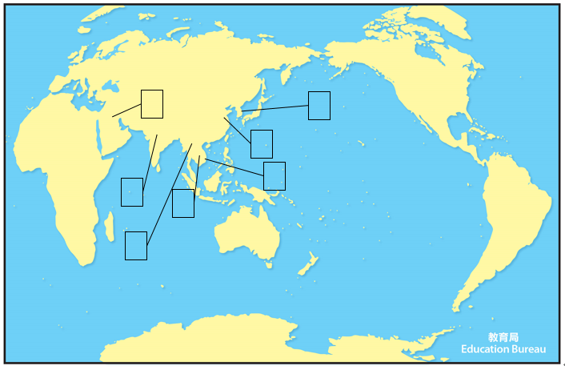
- 地圖中列出曾經設置宦官的地方，請在方格上填上適當的英文代號。(The map shows the past locations where eunuchs existed. Please write down the appropriate letters in the boxes.)
A | 明朝(Ming Dynasty)  (1368年―1644年)
B | 鄂圖曼帝國(Ottoman Empire)  (1299年－1922年)
C | 德里蘇丹國(Delhi Sultanate)  (1206年－1526年)
D | 阿瑜陀耶王國(Ayutthaya Kingdom)(1351年－1767年)
E | 貢榜王朝(Konbaung Dynasty)(1752年－1885年)
F | 李朝(Lý Dynasty)  (1009年－1226年)
G | 朝鮮王朝(Joseon Dynasty) (1392年－1897年)

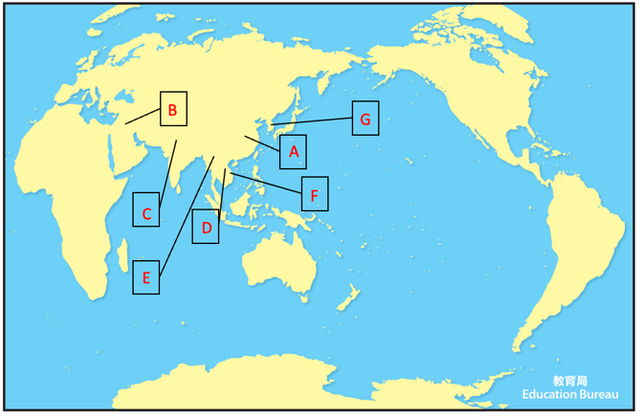
答案(Answer)：

A | 明朝(Ming Dynasty)  (1368年―1644年)
B | 鄂圖曼帝國(Ottoman Empire)  (1299年－1922年)
C | 德里蘇丹國(Delhi Sultanate)  (1206年－1526年)
D | 阿瑜陀耶王國(Ayutthaya Kingdom)(1351年－1767年)
E | 貢榜王朝(Konbaung Dynasty)(1752年－1885年)
F | 李朝(Lý Dynasty)  (1009年－1226年)
G | 朝鮮王朝(Joseon Dynasty) (1392年－1897年)

資料三：豹房軍士的銅牌(Source C: Bronze Warrior Plate in Leopard House)
中國國家博物館(National Museum of China)
http://en.chnmuseum.cn/collections_577/collection_highlights_608/artifacts_handed___down_from_ancient_times_612/202008/t20200811_246884.html (英文 English)

http://www.chnmuseum.cn/zp/zpml/csp/202008/t20200826_247452.shtml (中文 Chinese)

(中文 Chinese)
(英文 English)

這個銅牌由飼養豹子的軍士所攜帶。(This plate was to be carried by a government warrior who keeps leopards.)

明武宗(公元1491-1521年)興建豹房供玩樂之用。(Emperor Wuzong of the Ming Dynasty (1491-1521) built Leopard House for fun.)
豹房建成後，他經常留在那裡，很少管理政務。(After the Leopard House was built, he frequently stayed there and seldom managed government affairs.)
朝廷由宦官掌控。(The court was dominated by eunuchs.)

根據資料三，回答以下問題。(Study Source C, and answer the questions.)

4. 豹房是皇帝玩樂的地方。(Leopard House was the place for the emperor in having fun.)

5. 請推斷為何宦官得以弄權？請剔選正確答案。答案可多於一個。(Try to infer why did eunuchs get power? Please tick the correct answer. There may be more than one correct answer.)
皇帝昏庸無能(The emperor was incompetent)
皇帝只顧玩樂(The emperor only cared about entertainment)
皇帝年紀太少(The emperor was too young)

資料四：東林黨(Source D: Donglin faction)
東林黨是晚明時期的一群學者官員。他們批評只顧謀取私利，令吏治敗壞的宦官。他們在1620年代被宦官殺害。(The Donglin faction was a group of scholar-officials who were active in late Ming. They criticized eunuchs who worked for their own personal advantages and led to the corruption of the administration. Eunuchs who held power persecuted them in the 1620s.)

根據資料四，回答以下問題。(Study Source D, and answer the questions.)

6. 明代宦官弄權，最終導致哪次黨爭? 試圈出答案。(Study Source J, eunuchs abused power in the Ming Dynasty. Which factional struggle did they eventually lead to? Circle your answer.)
A. 戚宦黨爭(factional struggle between relatives of imperial consort and eunuchs)
B. 東林黨爭(Donglin factional struggle)
C. 新舊黨爭(factional struggle between reformists (New Party) and anti-reformists (Old Party))
D. 牛李黨爭(Niu-Li Factional Strife)

7. 宦官專權有何影響？試圈出答案。答案可多於一個。(What were the impacts of the power abuse of eunchs? Circle your answer. There may be more than one correct answer.)
A. 陷害忠良(Loyal and good men were persecuted)
B. 控制天子(The emperor was being controlled)
C. 誹謗朝廷(The imperial court was defamed)
D. 吏治腐敗(The administration was corrupt)

小總結 (A short summary)
宦官不是中國獨有的。(Employment of eunuchs in the court is not unique to China.)
宦官的主要工作及政治影響：作為後宮的僕人，以及作為皇帝的內侍。宦官在後宮的地位經常使他們能夠對皇帝施加重要影響，甚至使自己掌握大權。(Their main duties and the political influence of eunuchs were being a servant in the harems and as chamberlains to the emperors. Eunuchs’ positions in the harems enabled them to exert important influence over their royal masters and even to raise themselves to positions of great powers.)

課節四：晚明政局與明朝滅亡(Politics in the Late Ming Dynasty and the downfall of the Ming Dynasty)

皇帝昏庸，宦官亂政，朝政敗壞。(The emperors were incapable so the eunuchs abused power. The administration of the state was corrupt.)
晚明出現天災，民變四起。(In the late Ming Dynasty, there were natural disasters and peasant uprisings.)
最後清兵入關，明朝滅亡。(Qing troops entered the Shanhaiguan Pass and the Ming Dynasty collapsed finally.)

資料一：明朝時間線(Source A:The timeline of the Ming Dynasty)
D
AD
公元
C
A
B

1360 1390 1420 1450 1480 1510 1540 1570 1600 1630 1660

1. 在時間線上用「A」、「B」、「C」及「D」標示相關的歷史事件。(Please mark the historical events “A”, “B”, “C” and “D” on the timeline.)

年份(Year) | 歷史事件(Historical event)
1368年 | A. 明朝建立(The Ming Dynasty was established)
1556年 | B. 嘉靖大地震(Jiajing earthquake)
1633-1643年 | C. 明末大鼠疫(Great Plague in late Ming)
1644年 | D. 民變隊伍攻入首都，明朝皇帝自殺。(Rebels invaded the capital. The last Ming emperor committed suicide.  清兵入關，明朝滅亡。(Qing troops entered the Shanhaiguan Pass and the Ming Dynasty collapsed finally.)

資料二：《流民圖》 (Source B: Painting: Beggars and Street Characters)

請到以下網頁觀賞《流民圖》(Please visit the link below)：
https://ltfc.net/img/5d8779bb4aea654b0b3b3bde

《流民圖》背景：1516年 (The background of the Painting: Beggars and Street Characters: 1516)
明朝皇帝只顧玩樂，偏袒宦官，貪污腐敗。各地人民起事，百姓流離失所。(The Emperor of the Ming Dynasty only cared about entertainment. He favored eunuchs, thus contributing to administrative corruption. There were uprisings in various provinces and people were homeless.)

根據資料二，回答以下問題。(Study Source B, and answer the questions.)

2.明末人民生活如何？(What was the living condition of the people in the late Ming Dynasty?)
民不聊生(The living condition of the people was intolerable)

3. 這反映明末政局如何？試圈出答案。答案可多於一個。(How did this reflect the political situation in the late Ming Dynasty? Circle your answer. There may be more than one correct answer.)
A. 吏治腐敗(The administration was corrupt)
B. 宦官結黨營私(Eunuchs ganged up for selfish interests)
C. 政出多門(There were conflicting policies from different departments of government)
D. 濫用民力(There was abusive use of manpower)
E. 皇帝昏庸(Emperors were incapable)

資料三：1556年嘉靖大地震(Source C: Jiajing earthquake of 1556)
請觀看(Please view) 普通話附簡體中文及英文字幕 (Putonghua with simplified Chinese and English subtitles)
https://baike.baidu.com/video?lemmaId=2612240&secondId=25025142

資料四：各地大地震(Source D: Earthquakes of different places)
年份(Year) | 地震(earthquake) | 地點(venue) | 死亡人數(death toll)
1138年 | 阿勒頗大地震(Aleppo earthquake) | 敘利亞(Syria) | 230,000
1556年 | 嘉靖大地震(Jiajing earthquake) | 中國(China) | 830,000
2005年 | 喀什米爾大地震(Kashmir earthquake) | 喀什米爾地區(Azad Kashmir) | 87,350
2015年 | 尼泊爾地震(Nepal earthquake) | 尼泊爾(Nepal) | 7,600
根據資料三及四，回答以下問題。(Study Sources C and D, and answer the questions.)
4. 以下哪一場地震造成死亡人數最多？試圈出答案。(Which of the following earthquake caused the highest casualties? Circle your answer.)
A. 阿勒頗大地震(Aleppo earthquake)
B. 嘉靖大地震(Jiajing earthquake)
C. 喀什米爾大地震(Kashmir earthquake)
D. 尼泊爾地震(Nepal earthquake)

5. 嘉靖大地震造成多少人死亡？(How many people lost their lives in the Jiajing earthquake?)
830,000

6. 為何嘉靖大地震造成大量死亡？(Why did the Jiajing earthquake cause the highest casualties?)
A. 地震時正值冬天，災民凍死和餓死(It was winter during the earthquake. The victims died of freezing and starvation.)
B. 明政府救治無能(The government of the Ming Dynasty was incapable to save the people.)
C. 以上皆是(all of above)
資料五：明末大鼠疫(Source E: The Great Plague in the late Ming Dynasty)
明末大鼠疫在1633年起始於山西地區，1643年北京城內爆發重大疫情，造成20多萬人死亡，被認為是明朝在1644年滅亡的原因之一。(The Great Plague in the late Ming Dynasty started in Shanxi Province in 1633.The plague caused the deaths of more than 200,000 people in Beijing in 1643 and contributed to the collapse of the Ming Dynasty in 1644.)

資料六：以下是在不同時期發生的一些主要流行病：(Source F: Here are some of the major pandemics that have occurred over time:)
時期(time period) | 名稱(name) | 地區(region) | 死亡人數(death toll)
541-542 | 查士丁尼大瘟疫(Plague of Justinian) | 拜占庭帝國(Byzantine Empire) | 3千萬 - 5千萬(30-50 million)
1347-1351 | 黑死病(Black Death) | 歐洲(Europe) | 2億(200 million)
1633-1643 | 明末大鼠疫(Great Plague in the late Ming Dynasty) | 中國(China) | 20多萬(More than 200,000)
1894 | 甲午鼠疫(Plague of 1894) | 廣州、香港、廈門等(Guangzhou , Hong Kong, Xiamen, etc.) | 10萬(100,000)

根據資料五及六，回答以下問題。(Study Sources E and F, and answer the questions.)

7. 明末大鼠疫促使明朝在1644年滅亡。以下哪項不是明末大鼠疫所造成的影響？試圈出答案。(The Great Plague in the late Ming Dynasty led to the collapse of the Ming Dynasty in 1644. Which of the following was not the impact of the Great Plague? Circle your answer. )
A. 破壞了明朝的税源(The epidemic destroyed the source of taxes of the Ming Dynasty)
B. 摧毀了明軍的戰鬥力(The epidemic destroyed the fighting power of the Ming army)
C. 促成民變(The epidemic led to rebellions)
D. 導致武人專政，以兵變奪取帝位(The epidemic contributed to the domination of power by military men. They staged mutinies and forced the emperor to abdicate)

8. 流行病造成甚麼影響？(What was the impact of the pandemics?)
人口大量死亡(a massive drop in the population)

資料七：李自成 (Source G:Li Zicheng)

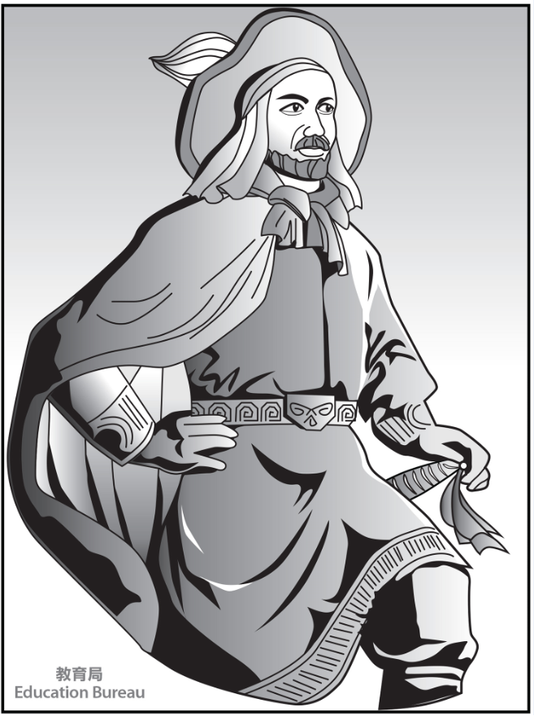
我是李自成，民變的領袖。在1644年，我和民變隊伍攻佔首都。明朝皇帝自殺，明朝滅亡。(I am Li Zicheng. I am the rebel leader. My rebel companions and I captured the capital of the Ming Dynasty. The emperor of the Ming Dynasty committed suicide. The Ming Dynasty collapsed in 1644.)
可是，我被滿清打敗。(However, I was defeated by the Manchus.)

根據資料七，回答以下問題。(Study Source G, and answer the questions.)

9. 誰是明末民變的領袖？(Who was the rebel leader of the late Ming Dynasty?)
李自成 (Li Zicheng)

10. 哪個是明末的外來威脅？(What was the foreign threat in the late Ming Dynasty?)
滿清(Manchus)

資料八：粵劇《帝女花》之香夭(Source H: Cantonese Opera “Double Suicide” from “The Flower Princess”)
請閱讀網站內相關資料及觀看粵劇影片(Please read the relevant information on the website and watch the Cantonese Opera video)：

https://www.eduhk.hk/ccaproject/yueju/eng/doubleSuicide.php (英文English)
https://www.eduhk.hk/ccaproject/yueju/ch/doubleSuicide.php (中文Chinese)

(中文Chinese)
(英文English)

根據資料八，回答以下問題。(Study Source H, and answer the questions.)

11.以下哪項是《帝女花》的故事背景？試圈出答案。(Which of the following was the background of the“The Flower Princess”? Circle your answer.)
A. 朱元璋推翻元朝，建立明朝。(Zhu Yuanzhang was the founder of the Ming Dynasty that took over the rule from the Yuan Dynasty .)
B. 明熹宗時，宦官魏忠賢專攬權力。(During the reign of Emperor Xizong of the Ming Dynasty, the eunuch, Wei Zhongxian, manipulated power.)
C. 明朝崇禎皇帝末年內憂外患嚴重。(Towards the end of the reign of the Emperor Chongzhen of the Ming Dynasty, internal turmoil and external threats became more serious.)

12. 明朝滅亡後，誰統一天下，建立新的朝代？試圈出答案。(After the downfall of the Ming Dynasty, who unified the country and established a new dynasty? Circle your answer.)
A. 清帝(The Qing emperor)
B. 長平公主(The princess Changping)
C. 周世顯(Zhou Shixian)

13. 請分享與你族裔歷史有關的戲劇 / 戲曲 / 故事。可以口語回應。(Please share dramas / operas / stories related to the history of your ethnic minority. You can respond verbally.)
(學生可自由作答)

小總結 (A short summary)
明末大鼠疫促使明朝滅亡。(The Great Plague in late Ming contributed to the collapse of the Ming Dynasty.)
1644年，民變隊伍入京引致崇禎皇帝自殺。(In 1644, the rebels entered the capital of the Ming Dynasty. Emperor Chongzhen committed suicide.)
清兵乘時入關，終致明朝滅亡。(Qing troops entered the Shanhaiguan Pass and the Ming Dynasty collapsed finally.)

如對本教材有任何意見，可聯絡課程發展處個人、社會及人文教育組：
黃浩明先生（erichmwong@edb.gov.hk; 35406829）或
羅嘉恩女士（lokayan@edb.gov.hk; 28925882）

